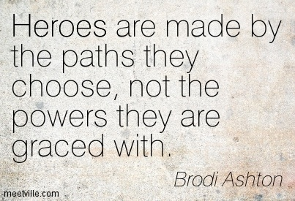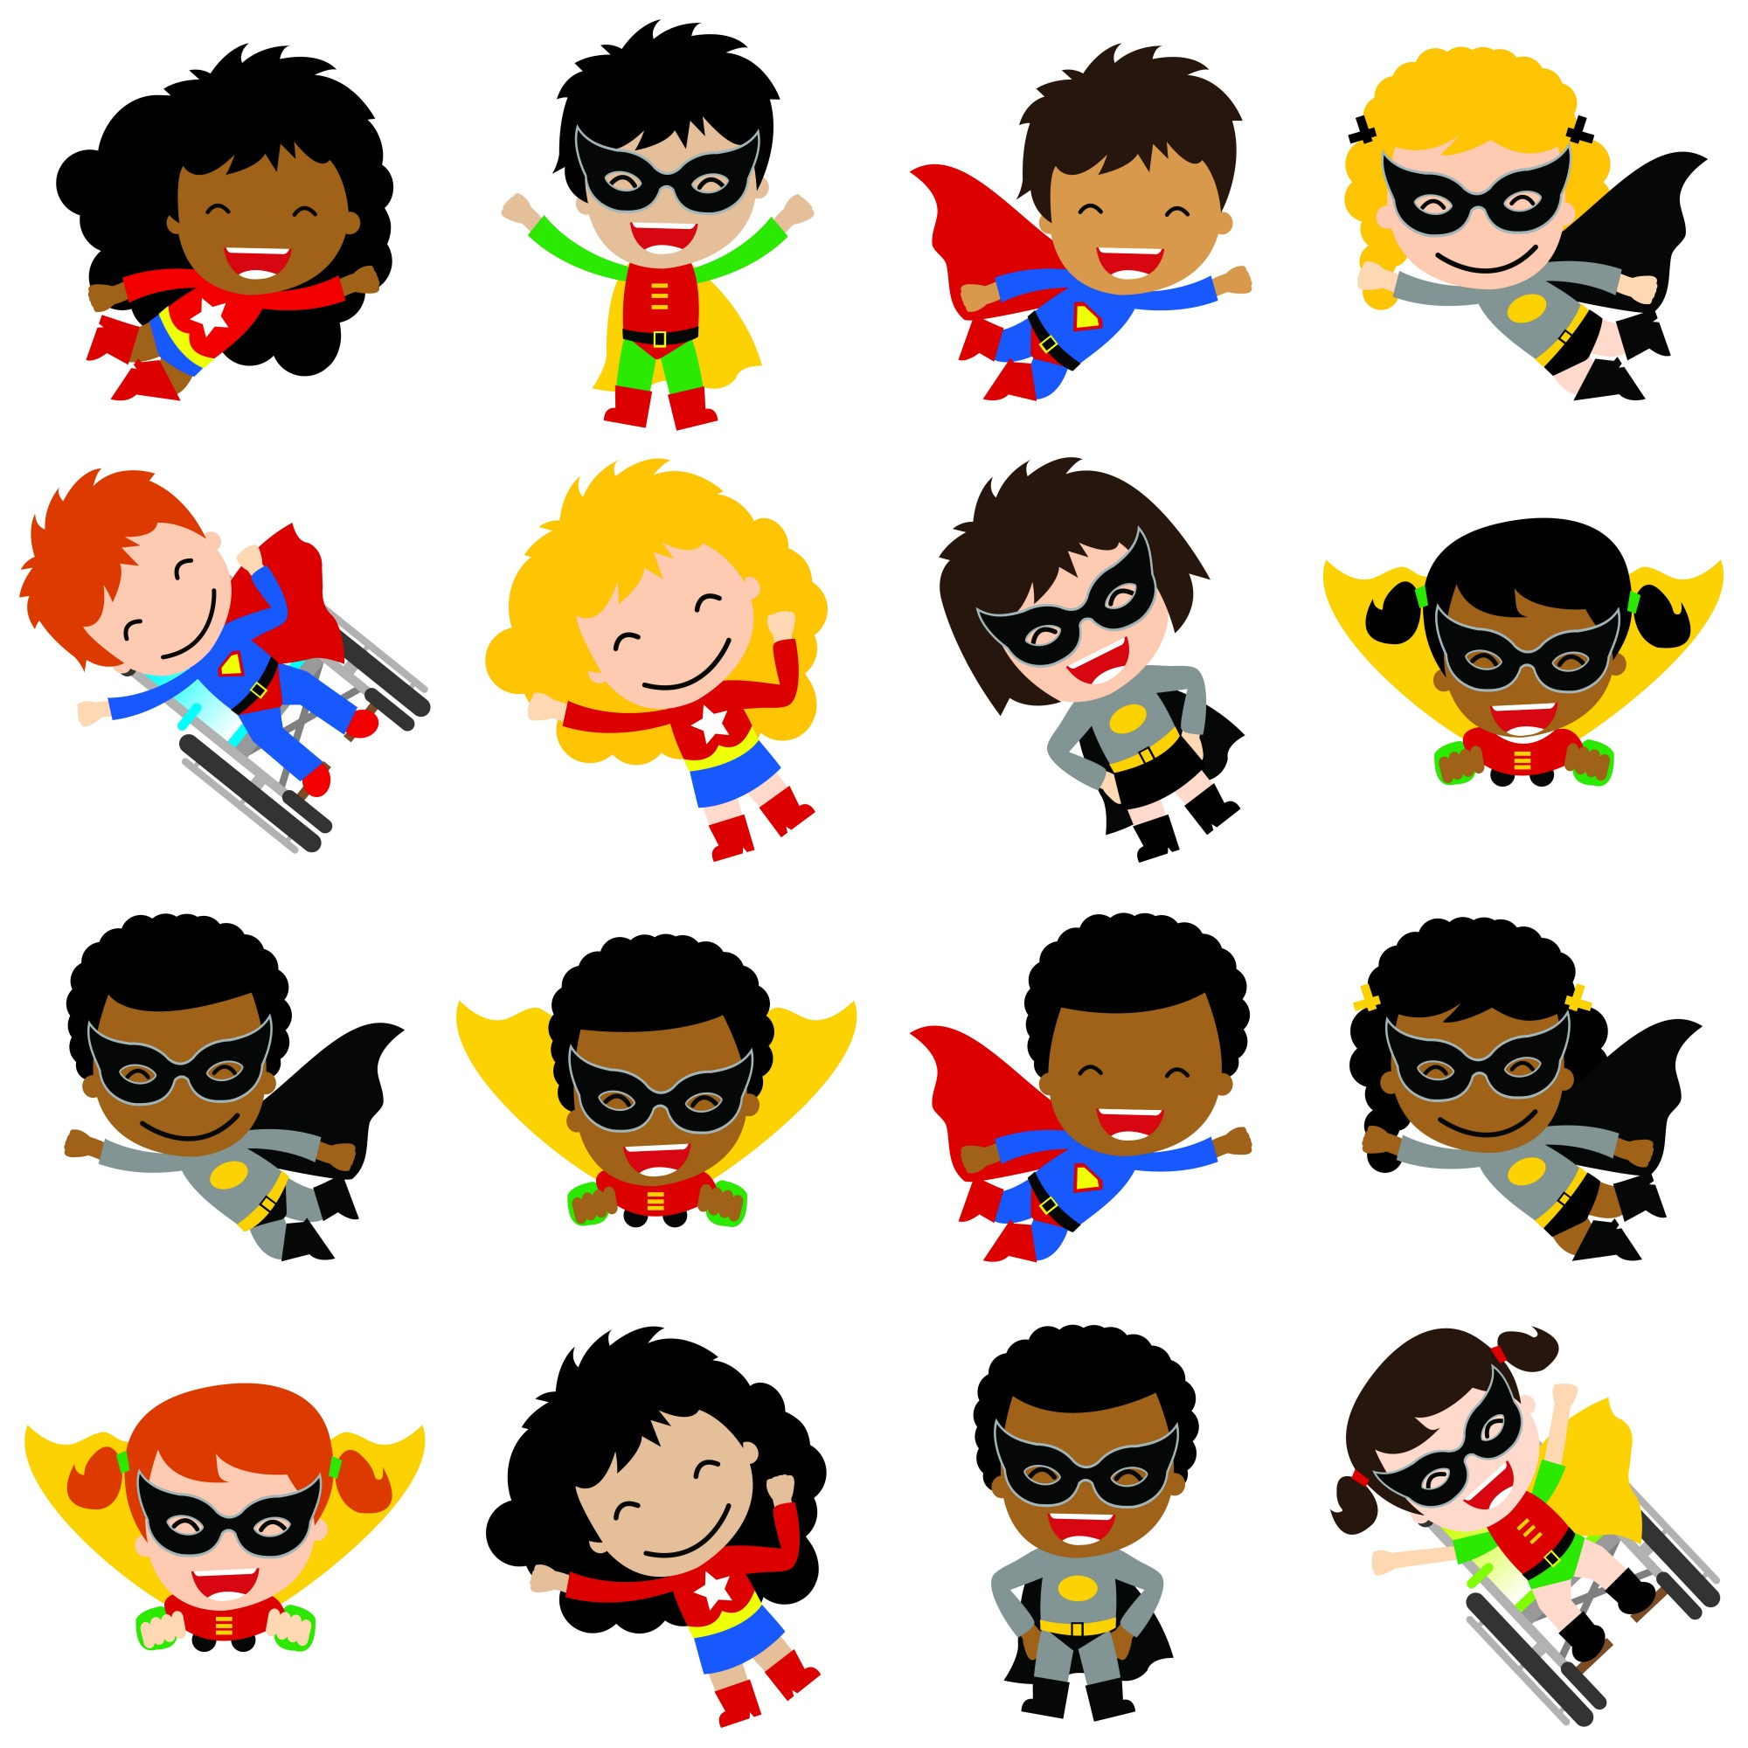

# Classroom Behavior

Welcome

to

3rdGrade

Mrs. Johnson

Behavior Guidelines

Students will be part of a “house”/group and will help their house earn points for using good manners and for being good leaders at school. Each 9 weeks we will have a class celebration to honor the house/group that has earned the most points so far in the year. Students can earn tokens from other teachers for good manners and for being a good leader, which can help them earn house/group points.

We have 5 classroom rules and when students choose not to follow those rules the following consequences will be the result:

1.Verbal warning and note home.

2. Write a note home and a call to parent from teacher.

3. Write a note home and a request for a conference with parent.

Hello Students and Families,

My name is Lynn Johnson. I am married and have a 21year old son, a 18month old daughter, and a foster son, who is 5 years old.

I received my Bachelor’s Degree in Education from Winthrop University and my Master’s Degree in Divergent Learners from Columbia College. I have my National Board certification in the area of Literacy. I am also a Gifted and Talented endorsed teacher.

I am honored to have your child in my class this year and will do all that I can to help him or her have successful learning experiences this year. Throughout the year, if you feel that your child needs extra help with any content, please contact me so that we can determine what resources will be most helpful in your child’s learning. I look forward to working with you and your child and having a uper year! Love,

Mrs. Johnson

# Your Teacher

🙞 🙜

## Q&A

My cell phone number is – 803-517-0197

My email address is – [ljohnso@rhmail.org](mailto:ljohnso@rhmail.org)

Our class web page is- <http://mrsjthirdgrade.weebly.com>

Students will take some tests on the following website. You will be able to log in to the site to see your child’s graded test on Canvas. I will send home login information very soon.

Every night your child will bring home a homework folder, to help keep you informed about assignments as well as daily behavior. Please sign the homework sheet nightly. Students will turn in this folder each morning, if you have a note for me please send it in this folder. You can also email me at [ljohnso@rhmail.org](mailto:ljohnso@rhmail.org).

Students will be expected to read every night for 20mins. Math homework will be given nightly as well.

Students can bring in birthday treats on their special day, we have 23 students in our class this year.

As a 3rd grader, your child will receive letter grades. While some projects will be graded using a point scale of 1-4, everything graded will be scaled so that a letter grade is give (A,B,C,D or F). Please contact me if you have any questions.

Students will use an ipad throughout the day for various assignments.

Students can access Mobymax from home, this is an excellent website that allows students to login and practice math and language arts. Students are able to use their school login information at home.

If you would like to visit our classroom, please just give me a call or send an email. You are welcome to come anytime.

If you are interested in helping in the classroom this year, please call or email me as soon as possible.

# Welcome to 3rd Grade